**Invisible biodiversity:** **widespread extinction debts and colonisation credits in US bird communities**

**Abstract**

Landscape modifications are a major source of biodiversity loss, but species responses to land cover change are not instantaneous. Extinctions and colonisations may take a long time to occur, leading to extinction debts and colonisation credits. If unaccounted for, debts and credits can lead to erroneous predictions of future biodiversity that may misinform conservation actions. Current attempts to measure debts and credits are limited in their spatial/temporal scale and do not consider multiple facets of landscape composition and history. Here, we quantify the relative contribution of past and current landscapes on the current effective number of species in 2880 US bird communities, explicitly measuring the biodiversity magnitude of these delayed responses to increases and decreases of five land cover types. We find that the current effective number of species is still largely explained by the past landscape composition, and thus that there are widespread extinction debts and colonisation credits. The extent of these legacy effects depends on the type, directionality and magnitude of recent land cover change. Specifically, we reveal debts across 52% of the US, particularly in recently urbanised areas, and colonisation credits in the remaining 48%, which were primarily associated with grassland decrease. We conclude that biodiversity policy targets risk being obsolete unless past landscapes are considered and debts and credits accounted for.

**Main**

Preventing an irreversible loss of biodiversity is one of humanity’s greatest contemporary challenges1. Anthropogenic habitat loss is recognised as a major driving force of species extinctions, threatening up to 85% of all species included in the IUCN Red List2. Current understanding of the impacts of habitat change on biodiversity is heavily reliant on the assumption that species respond rapidly to disturbances. However, the role that legacy effects and lags play in species’ responses to environmental change, is increasingly recognised 3–8.

The diversity of species at a given location is only partially determined by the current state of a habitat. Rather, it is the consequence of a legacy of complex historical effects of landscape change on community composition9,10. Notably, species’ responses to changes in land cover composition are rarely instantaneous, but instead subject to lags leading to gradual species extinctions and colonisations at the landscape scale7,11. Thus, current observations of biodiversity could be significantly higher than a recently modified landscape is actually able to support, generating so-called extinction debts. The opposite scenario, recent modifications that will, in time, be favourable to biodiversity, will instead lead to colonisation credits.

Extinction debts and colonisation credits form the focus of a growing area of research in community ecology7,11, but have rarely been explicitly incorporated into predictive models of biodiversity over large spatial scales4,5,12. This hinders our ability to correctly quantify future biodiversity loss and increases the risk of policy strategies being out-of-date before they are even introduced8. Moreover, the type and directionality of habitat change may result in different magnitudes of legacy effects and lagged responses, leading to spatial variation in debts and credits. However, so far, most studies have focused on the loss of either forests or grasslands, largely ignoring gains and other habitat types3,4,12,13. To generate predictions of biodiversity that can reliably inform environmental policies, the contribution of different types of past landscapes and subsequent legacy effects on the composition of current communities need to be quantified and incorporated into large-scale spatio-temporal models. Here, we developed the first such model using bird diversity data collected from 2880 bird communities over a 15-year period in the contiguous USA and validated our predictions using independent data from a more recent survey.

**Results**

***Modelling extinction debts and colonisation credits***

We calculated the species diversity of 2880 communities surveyed as part of the North American Breeding Bird Survey (BBS, Fig. S1, S2), which comprises information on the abundance of more than 500 bird species across the contiguous USA14. We defined a community as the assemblage of birds associated with the landscape surrounding each survey unit (i.e. not a prespecified habitat type). Birds are an ideal taxon for analyses of spatial and temporal biodiversity changes because they have long been monitored over broad spatial scales and they are highly sensitive to anthropogenic disturbance15. We chose the effective number of species rather than species richness as a diversity metric because it provides a more robust measure that is less sensitive to species rarity and detectability than species richness16,17. We also sourced high spatial resolution (30m2) land cover data from the National Land Cover Database (NLCD)18, as well as temperature data (mean across May and July) from the PRISM climate dataset19 (Fig. S3, Table S1). Using these datasets, we developed and fitted a Bayesian generalised mixed effects model (GLMM) describing the effective number of species in 2016 as a function of the weighted contribution of the landscape composition in 2016 and the past landscape composition in 2001 (hereafter: legacy model, as it incorporates information about both present and past landscape compositions). We then fitted a similar model only considering the landscape composition of 2016 (hereafter: equilibrium model, as it models the biodiversity we would expect in an equilibrium state of a static landscape with no legacies). By subtracting the effective number of species predicted by the legacy model from that predicted by the equilibrium model, we determined that colonisation credits were present if the difference was positive, and vice versa, extinction debts were present if the difference was negative. A lower effective number of species in the equilibrium model highlighted an extinction debt whereas a lower number in the legacy model spotlighted a colonisation credit.

Our fitted legacy model was able to accurately predict the observed effective number of species in 2016 (Pearson correlation test, r = 0.65, df = 4798, p < 0.01, Fig. S5). We further validated the model with more recent bird data from 201914, to confirm that the predicted debts and credits matched recently observed changes in effective number of species from 2016 to 2019. Without using any land cover change information from the same period, and despite the relatively short time interval (we expect most of these debts and credits will require more than three years before they become fully realised), changes in the effective number of species since 2016 have overall been in the direction predicted by our model (Pearson correlation test, R = 0.28, df=4233, p <0.001, Fig. S6).

Our analysis revealed the previously unknown extent of debts and credits across large areas of the contiguous USA (Fig. 1). Overall, 52% of this area is expected to lose species (extinction debts) and 48% to gain species (colonisation credits) (Fig. 1). Strikingly, many of the predicted debts are localised around metropolitan areas (e.g., Atlanta, Orlando, Chicago, Indianapolis, St. Louis and Houston). Conversely, predicted colonisation credits are largely concentrated in the Northeast, along the Appalachian Mountains and in less inhabited areas across the country. Neglecting such debts and credits could lead to overestimates of the effective number of species that a landscape can support by up to 42%, whereas in other locations to underestimates of up to 62%.

**Fig. 1.** **Extinction debts and colonisation credits across US bird communities.** The estimated distribution and magnitude of extinction debts (red) and colonisation credits (blue) across the contiguous USA. Debts and credits were calculated by subtracting the effective number of species predicted by the legacy model from that predicted by the equilibrium model. We estimated that 48% of the contiguous USA land area is, as of 2016, experiencing colonisation credits (equilibrium model - legacy model > 0) whereas 52% of it is experiencing extinction debts (equilibrium model – legacy model < 0). Note that the percentages shown in the pie chart are not the same as the map legend, which instead shows the 10% and 25% quantiles for both credits and debts. Uncertainty associated with these predictions is presented in Figure S7.

***Debts and credits are associated with the type, magnitude and directionality of land cover changes***

The debts and credits identified by our model originate from the substantial contribution of the past landscape on the current effective number of species (Fig. 2). Altogether, our results indicate that legacy effects are strong and pervasive for all land cover types, even for small magnitudes of change during a 15-year window. Indeed, a mere 10 % increase or decrease in any land cover type leads to a substantial weighting of the past land cover composition in explaining the current effective number of species (proportional contribution of past landscape > 0.6, Fig. 2F). Specifically, strong legacies were observed for gains of urban and cropland (Fig 2A, Fig. 2E), and for losses of grassland and cropland (Fig 2D, Fig. 2E). A 10% change in these land cover types led to the effective number of species being almost completely explained by the past land cover composition (proportional contribution of past landscape >= 0.9). Conversely, a loss of 10% of forest cover or a 10% gain of grassland were associated with less pronounced legacy effects (proportional contribution of past landscape = 0.68 and 0.67, respectively; Fig. 2B, Fig. 2D). Whether cover was lost or gained also mattered for legacy effects; for example, forest cover gain implied a stronger legacy effect than forest loss (Fig. 2B), while the opposite was true for grasslands. Taken together, our results highlight the importance of considering multiple attributes of land cover change over time: magnitude, type and directionality.

**Fig. 2.** **The contribution of past landscape to the current effective number of species depends on the type, amount and directionality of land cover change. (A, B, C, D, E)** Our model allowed us to quantify the proportional contribution of the past landscape in 2001 on the effective number of species in 2016 (y-axis), in response to positive and negative changes of different land cover types between the two time points (x-axis). A value of 0 on the y-axis indicates that the effective number of species in 2016 is completely explained by contemporary land cover whereas a value of 1 indicates that it is fully described by the land cover in 2001. All values presented are predictions under the assumption that no other land cover changes take place. Lines indicate the estimated mean value of the contribution of the past landscape, while coloured areas around each line represent 95% credible intervals. Lighter shaded regions are predictions outside of the maximum observed land cover change. **(F)** Values of the proportional contribution of past landscape (y axis, 0 to 1) associated with a 10% increase or decrease for each land cover analysed.

***Explaining the spatial variation in debts and credits***

***Spatial variation of land cover changes drives current debts and credits***

Land cover changes have not been homogenous across the contiguous USA (Fig. 3). For instance, much of the area in the central United States has experienced large scale conversion of grasslands (Fig. 3D) into croplands (Fig. 3E). Forest loss has been concentrated in the Northwest as well as along the Appalachian Mountains (Fig. 3B), where forests have been mostly converted to grasslands (Fig. 3D), including pasture. Urban development has occurred around major metropolitan areas across the entire US, although particularly in the East (Fig. 3A). In contrast, the vast areas of desert and shrubland of the Southwest have experienced only very limited land cover change. We hypothesised that some of the spatial patterns in debts and credits predicted by our model should reflect this spatial segregation of different types of land cover changes. To test this hypothesis, we modelled the magnitude of the predicted debts and credits as a function of changes in land cover. We found extinction debts to be significantly associated with urban and cropland gain, and with loss of wetland (Fig. 4 and Table S3). This is consistent with earlier findings that increases in cropland and urban cover are associated with declines in bird diversity20,21; similarly, wetlands are important habitats for birds22 and it is thus unsurprising that recent wetland loss is associated with extinction debts. We found that colonisation credits were only significantly associated with recent loss of grasslands. While this association might appear at first surprising, it could be a consequence of the inclusion of pasture within the grassland category of NLCD: because pastures are globally associated with reduced animal diversity23, the reduction of grassland might result in future benefits to biodiversity.

**Fig. 3. Maps of the contiguous USA showing the spatial distribution of each land cover change type included in the analysis** **(A, B, C, D, E).** Data represent the magnitude and directionality of change, in percentage points, between the years 2001 and 2016. Data was sourced from the open-access National Land Cover Database (NLCD) CONUS products developed by the US Geological Survey18. **(F)** Total area of negative and positive change for each land cover covariate between 2001 and 2016 in km2.

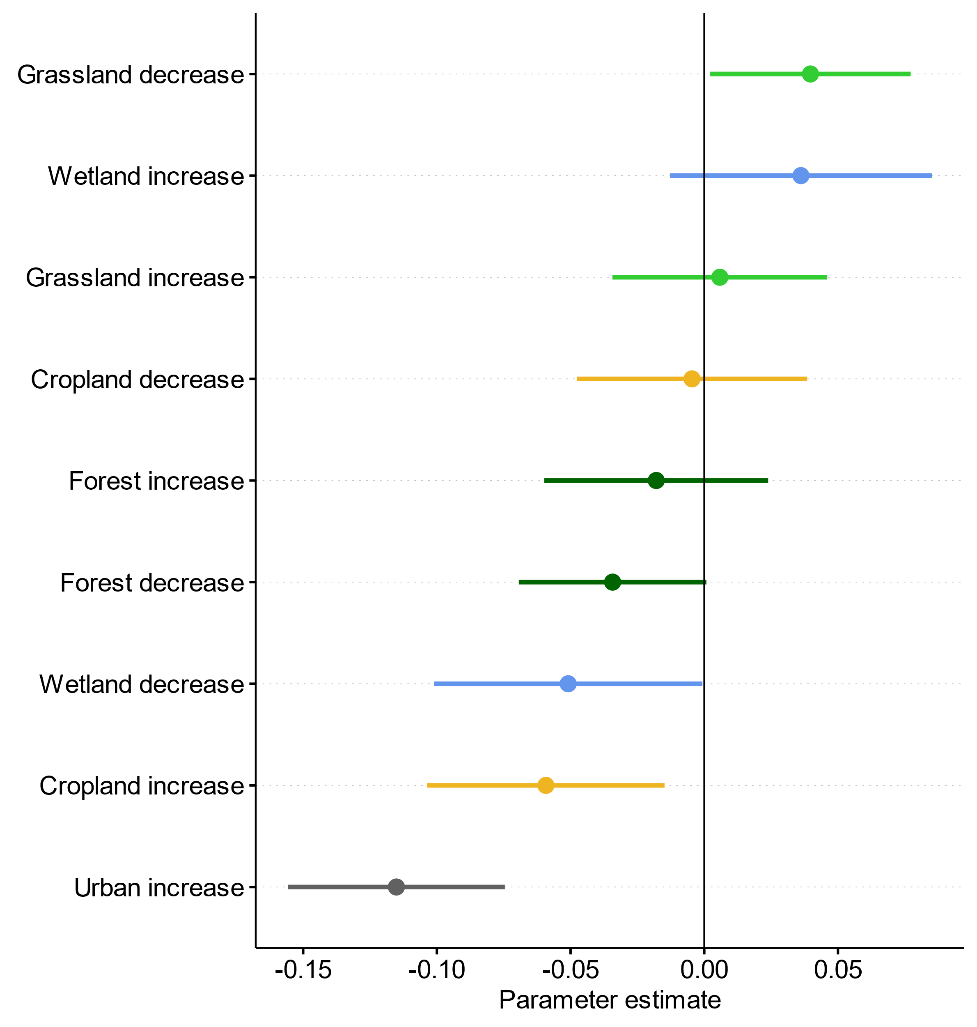**Fig. 4.** **Effect of land cover change on extinction debts and colonisation credits.** Coefficient estimates and credible intervals of different land cover change types of a Generalised Linear Model in which the response variable was the model-predicted magnitude of colonisation credits and extinction debts (see Fig.1) and the explanatory variables were the magnitudes of the positive or negative changes in the land cover types. Credible intervals are the result of uncertainty propagation by fitting the GLM to a 1000 sets of predicted values of debts and credits generated by posterior sampling. Subsequently, the parameters of each fitted GLM were sampled 1000 times before computing means and credible intervals, presented in the figure.

**Discussion**

By quantifying the geographical extent and magnitude of debts and credits we have revealed the invisible footprint of anthropogenic change on bird biodiversity at continental scale. Far from being a minor effect, we estimate that the mainland area of the USA is already committed to biodiversity changes, of different magnitudes, that have yet to become realised. Moreover, we emphasise that the legacy of past landscapes on the current biodiversity (effective number of species) is dependent not only on the type and amount of land cover change, but also on its directionality. By accounting for all these aspects in our model, we show the expected widespread distribution of future species extinctions and colonisations across a large geographical area. Our results spotlight areas of conservation concern, particularly around urban centres and in the Southeast US, a region that has already experienced catastrophic losses of avian diversity and abundance over the last 50 years15. We show that this decline is far from being over and that more avian diversity will be lost if urgent conservation actions are not put in place. However, extensive areas of the contiguous US are also predicted to gain species, particularly in the Northeast, but also in many other less populated locations that are close to areas predicted to be in debt. Nevertheless, we acknowledge that changes in effective numbers of species provide only a coarse measure of biodiversity change and that processes specific to species or functional traits could play a significant role in how communities respond to habitat change. We are also aware that our results are a first attempt to the quantification of biodiversity credits and debts over large spatial scales, and while this is a considerable improvement over assuming equilibria are reached instantaneously, additional information could be obtained by considering multiple time points over a longer time period.

Taken together, our results demonstrate that extinction debts and colonisation credits are widespread in avian communities across the US. This highlights the complex and dynamic nature of biodiversity responses to land use change. We argue that this complexity needs to be accounted for in predictive models to improve the projections of the impact of past, current and future habitat change on biodiversity, thus contributing to the conservation of biota worldwide.

**Methods**

All of the statistical analyses were conducted using the R programming language version 4.0.5 within the RStudio IDE version 1.4.124,25. Data visualisation and processing was performed with the *tidyverse* collection*, foreach* and *doParallel* R packages26–28. Geographical Information System (GIS) operations on raster and vector files were conducted using the *sf*, *exactextractr* and *raster* R packages29–31.

**Data sources and pre-processing**

***Biodiversity data***

We used the North American Breeding Bird Survey (BBS) dataset as our source of biodiversity data due to its long temporal coverage and spatial extent14,32. The BBS is composed of bird species abundance records collected since 1966 from over 4000 survey routes across the countries of Mexico, USA and Canada. For this study we focused solely on routes in the USA, due to their longer time dimension. Data collection follows public access roads that are 24.5 miles long (circa 39.2 km) using a point count protocol whereby routes are surveyed every half-mile (800 m) for a total of 50 stops. At each stop, observers stand for three minutes and record the species and the abundance of every bird seen or heard within 400 metres of their location. The routes are surveyed by volunteers with experience in bird observation, and surveys are conducted from late April to July to capture the peak of the breeding season.

We selected the years 2001 and 2016 as the two timepoints of our analysis. This 15-year time frame corresponded to the longest possible timespan for which land cover data products were available at high spatial resolution18. Prior to analysis, we subset the BBS dataset by removing routes that had incomplete survey lengths (less than 50 point count stops, indicated by the RouteTypeDetailID field value being less than 2 in the extracted BBS dataset) or that were surveyed under adverse weather conditions such as high wind and rain (as indicated by the Run Protocol ID field being equal to 1), which could affect bird occurrence and detectability. Following this filtering process, the total number of BBS routes analysed was 960.

For higher precision when inferring the relationship between avian diversity and environmental variables, we subdivided each route into five segments of equal length, consisting of 10 count locations each. This approach was motivated by the need to more closely associate bird communities with the land cover composition in the area in which they are found. To minimise the spatial autocorrelation between subsequent segments and avoid overlaps in landscapes analysed we filtered the data to keep only the first, third and fifth segment of each route. These segments therefore formed our sampling unit used in all analyses.

We recognised that environmental conditions and stochastic trends in populations could introduce variability in biodiversity calculated from bird community data. We therefore extracted, for each segment and each species, the average population count across a three year period centred on our two timepoints (2000, 2001, 2002 and 2015, 2016, 2017)33. We then calculated the mean abundance of each species across these three years.

The effect of observer experience34–36 was accounted for by sourcing the observer ID responsible for each route at each timepoint and including it as random effect in the legacy model (see “Model development” section). We also controlled for the time of day as it is plausible to expect visibility and avian species activity patterns to vary between early morning and later parts of the day. Time of day for each segment was calculated by averaging across the start and end time data entries associated with each route, and then including this as covariate in both the legacy and equilibrium model (see “Model development” section). However, we did not model detectability issues associated with traffic noise and disturbance. Firstly, this is because all BBS survey are conducted along public access roads with a vehicle, so the disturbance is expected to be similar across sites, and secondly because previous studies have found no clear evidence for noise being the main cause for reduced bird abundance near roads37.

Following these procedures, our processed BBS dataset included entries of mean abundances of each species for a total of 2880 segments, corresponding to segment 1, 3 and 5 of 960 routes (Fig. S1). For each segment, at each timepoint we calculated different measures of alpha diversity following the Hill numbers framework38. We then selected to use the effective number of species at q=1, calculated as the exponential of the Shannon-Wiener Index38. The effective number of species at q=1 sits at the theoretical half-way point between the classic species richness measure that accounts only for the absolute number of species (q=0) and the Berger-Parker dominance index (q=infinity), which instead only reflects the most common species. Thus, the effective number of species is a robust alternative to species richness which does not take account of species rarity or detectability and thus can lead to biased biodiversity estimates16,17.

***Land cover and environmental data***

Land cover data for the United States of America for our focal years of 2001 and 2016 were sourced from the open-access National Land Cover Database (NLCD) CONUS products developed by the US Geological Survey18,39. The NLCD products are high-resolution (30m pixel dimensions) classified raster files covering the land area of the whole USA. This dataset provides us with the opportunity to look at finely gridded spatio-temporal changes in a landscape over a relatively long time frame of 15 years, while utilising data collected and analysed with the same methods (e.g. land use classification algorithms).

To reduce the number of potentially collinear explanatory variables included in our models, we aggregated the land cover variables provided by the NLCD dataset. We summarised these to five land cover categories: *urban* [an aggregate of the Developed-Open Space (sub-class 21), Developed-Low Intensity (22), Developed-Medium Intensity (23), Developed-High Intensity classes]; *forest* [an aggregate of the Deciduous Forest (41), Evergreen Forest (42), Mixed Forest (43) classes]; *grassland* [an aggregate of the Shrub (52), Grassland/Herbaceous (71), Pasture/Hay (81) classes]; *cropland* [cultivated Crops (82) sub class] and *wetland* [an aggregate of the Woody Wetland (90) and Herbaceous Wetland (95) classes]. The Perennial Ice/Snow (12), Open Water (11) and Barren Land (31) classes were excluded from the analysis as they were very uncommon in our dataset. The distribution and total area of the land cover categories across the US is shown in Fig S3, S4. Temperature data was sourced from the 30 arc-seconds gridded PRISM climate database19 and was extracted as the mean across May and June for each group of years from which bird abundances were taken.

We first sampled the landscape surrounding each segment using a range of buffer shapes and sizes and then selected based on the capacity of each buffer type to explain the response variable. The types of buffers that we explored were: a circular buffer around the centroid of the polygon defined by the vertices of each segment (4000m radius) and a series of three buffers around the segment line (500m, 2000m and 4000m radius). The best fit was given by the smallest buffer size of 500m, shown in Fig S2, which also coincides with the BBS protocol effective counting distance of 400 metres and more closely reflects the size of bird territories14. Land cover variables were computed as a percentage of the total buffer area. Change in percentage points for each land cover type between the two years was computed by subtracting the values at the two timepoints. A change product is also provided by the USGS databases40, but it does not meet our needs because it considers land cover changes based on a ranking. Nonetheless, a comparison of urban land cover change between the timepoints showed a similar result (Fig. S8). Land cover data were processed geospatially using the NAD 83 Conus Albers Coordinate Reference Systems projection, EPSG 5070.

**Model development**

***Theoretical background***

We developed a statistical model that conceptualised extinction debts and colonisation credits by combining the following two concepts: (1) the settled biodiversity of avian communities in a given landscape composition (i.e. a system at equilibrium) and (2) the lagged response in the species diversity in a given landscape due to recent land cover changes (i.e. a system moving to a new equilibrium). We reasoned that, given enough time, and with no further changes in land cover, the effective number of species at a given location would eventually equilibrate. The equilibrium distribution of the effective number of species emerges with the waning of the legacy effect of previous landscape compositions in encouraging or impeding the recruitment and survival of particular species. We did not model these ecological mechanisms directly, but instead expressed the equilibrium of the effective number of species, and the rate of approach to this equilibrium, as empirical functions of environmental covariates. It is important to keep in mind that during a finite time interval following environmental change, it is likely that our observations of effective number of species represent a system in a transitory state towards its new equilibrium. Yet, environmental changes may occur at rates that never allow the system to equilibrate. Although the equilibration processes are latent (i.e. not amenable to direct observation), the combination of equilibrium and temporal legacy components into an integrated model, applied to a dataset with extensive environmental replication (due to spatial expansiveness), has allowed us to retrieve distributions for all relevant model parameters (see below).

***Model overview***

The observed effective number of species $R_{s,t}$ at site $s$ in year $t$ for $t=t1, t2$ is modelled as a normally distributed variate with mean $µ_{s,t}$ and standard deviation $σ$

|  |  |
| --- | --- |
| $R_{s,t}∼Normal\left(µ_{s,t},σ\right)$. | [1] |

We assume that, under landscape change, the system is in a state of flux and that the data are from observations witnessing the transition between two (unattained) equilibria. The expected state of the system at any given point in time $µ_{s,t}$ was formulated as a mixture of past and future equilibrium distributions (i.e. a weighted average of the two distributions, where the weights are given by the complementary proportions $ω$ and $1-ω$)

|  |  |
| --- | --- |
| $µ_{s,t}=f\left(x_{s,t};β\right)ω\left(y_{s,t};γ\right)+f\left(x_{s,t};β\right)\left(1-ω\left(y_{s,t};γ\right)\right)$. | [2] |

Here, the function $f$ describes the equilibrium distribution of the effective number of species as a function of the configuration of the local environment, captured in covariates $x_{s,t}$. The weighting function $ω$ depends on covariates $y_{s,t}$ derived from the difference in the local land cover between 2016 and 2001 (i.e. is a function of the land cover change that has taken place). The mixture weights $ω$ and $\left(1-ω\right)$ determine the relative importance of the two equilibrium distributions (past or current). For example, if $ω=1$, the interpretation is that the new equilibrium distribution has been completely attained, and thus the current (2016) effective number of species is entirely explained by the current (2016) land cover. Conversely, when $ω=0$, the current effective number of species is entirely explained by the past (2001) land cover. The vectors of parameters $β$ and $γ$, presented in Equation [2], are inferred from model fitting.

We also augmented Equation [2] with a function *g* of static covariates and random effects $z$ which we expect to have an impact on the effective number of species. Thus, the model comprised equilibrium components, a temporal legacy component and static covariates:

|  |  |
| --- | --- |
| $$µ_{s,t}=f\left(x_{s,t_{2}};β\right)ω\left(y_{s,t_{1},t_{2}};γ\right)+f\left(x_{s,t_{1}};β\right)\left(1-ω\left(y_{s,t_{1},t_{2}};γ\right)\right)+g\left(z_{s};α\right)$$ | [3] |

in which $f\left(x_{s,t};β\right)$ are the equilibrium components for the two timepoints, $ω\left(y_{s,t_{1},t_{2}};γ\right)$ is the temporal legacy component, and $g\left(z_{s};α\right)$ is the function that captures the static covariates and random effects.

***Equilibrium components***

We defined the equilibrium distribution of the effective number of species at a given timepoint as a function $f\left(x_{s,t};β\right)$ of land cover. This function describes the expected effective number of species at location *s*, given sufficient time for the community to adapt to the given land cover composition. We now describe this function in more detail.

The equilibrium component was formulated as a log-linear model comprising a total of $I=5$ environmental covariates (the percentage cover of five landscape classes: urban, forest, grassland, wetland and cropland), using 2nd-order polynomial terms, captured by the coefficient *j*, to account for optima in effective number of species along each of the six environmental dimensions:

|  |  |
| --- | --- |
| $$f\left(x_{s,t}\right)=exp\left(β_{0}+\sum_{i=1}^{I=5}{\sum_{j=1}^{J=2}{β_{i,j}}}x_{i,s,t}^{j}\right)$$ | [4] |

In Equation [4], the *β* parameters capture the effect of covariates on the equilibrium and are assumed to be the same for each environmental composition. A simplifying assumption necessary for the application of this model is that the effective number of species had equilibrated at the first time point. As data become available for more years in the future, the influence of this assumption on the model results will diminish and more accuracy will be achievable with multiple time points.

To allow for conditionality in the effects of one land cover variable on the response of the effective number of species to another land cover variable, we extended this function with pairwise interaction terms *k* between all the linear terms for land cover variables and pairwise linear-quadratic terms, as follows:

|  |  |
| --- | --- |
| $$f\left(x_{s,t}\right)=exp\left(β_{0}+\sum_{i=1}^{I=5}{\sum_{j=1}^{J=2}{β_{0,i,j,}}}x_{i,s,t}^{j}+\sum_{i=1}^{I=5}{\sum_{k=i+1}^{K=6}{{β_{1,i,k}x}_{i,s,t}x_{k,s,t}}}\right)$$ | [5] |

***Temporal legacy component***

The main covariates $x_{i,s,t_{1},t_{2}}$ for the part of the model that captures the temporal legacy $ω\left(x_{s,t_{1},t_{2}};γ\right)$ are derived from the change in land cover ($Δx_{i,s}=x_{i,s,t_{2}}-x_{i,s,t_{1}}$) between the two timepoints

|  |  |
| --- | --- |
|  | [6] |

where ${Δx}_{s,t,z}$ is a vector of the *i*th environmental change variable (i.e. urban, forest, grassland, wetland, cropland) at site *s* and for directionality *z.* The effect of these covariates on the mixture weights is given by:

|  |  |
| --- | --- |
| $$ω\left({Δx}_{s,t_{1},t_{2}}; γ\right)=exp\left(\sum_{i=1}^{I=5}{{-γ}_{i,z}{Δx}_{z,s,i}}\right)$$ | [7] |

This formulation weights the contribution that the environmental variables at the two timepoints have on the current effective number of species, as a function of the magnitude and directionality of change in each type of land cover covariate. The $γ$ parameters, and subsequently the temporal legacy component, are allowed via the inclusion of the environmental change data $Δx_{s,t,z}$, to account for the distance between the land cover at the two timepoints, therefore quantifying how far the initial community would need to travel to reach equilibrium in 2016 as a function of the type, magnitude and directionality of change. It should be noted that our model, in equation [3], is only implicitly related to the speed with which the effective number of species reacts to environmental changes. Instead, it quantifies how much further it would still have to travel to reach the expected equilibrium associated with the current configuration of the landscape.

***Static covariates***

As described in the model equation [3], we included a function of static covariates to which we can expect the effective number of species respond without lags relating to the past landscape. We added a linear and quadratic fixed effect for temperature in 2016 to control for any difference in the effective number of species related to climatic characteristics and to allow for a parabolic relationship to be expressed (optima either at mean or extremes values). We also controlled for the heterogeneity of a landscape by including the effective number of land cover types, computed in the same way as the effective number of species, as a fixed effect40. A fixed effect for time of day, reflecting the time at which each segment was surveyed, was included to correct for differences in species detectability between early morning and later parts of the day41. An observer-level random effect was also added to control for variation between observers35,36 and partly account for between-route variation, given that we would expect observers who collect data from multiple routes to do so within a relatively small area. Spatial autocorrelation of the effective number of species was tested for all segments at once and by different radiuses for neighbour inclusion (500m, 1000m, 5000m, 10000m, 100000m), using the Moran’s I statistic42. Spatial autocorrelation was not corrected for because Moran’s I was not significant at any spatial scale (p>0.05). Pseudo-replication between neighbouring segments was avoided by considering segments 1, 3 and 5, whose land cover buffers did not overlap (Fig. S2).

**Model fitting**

The model was fitted within a Bayesian framework using a Hamiltonian MCMC algorithm implemented in the STAN programming language43 version 4.3.0 and the cmdstanr R package version 2.26.144.

We ran 4 chains, sampling for 1000 iterations with a burn-in period of 500 iterations each. These numbers of iterations were sufficient to achieve chain convergence. The STAN sampling was run on four parallel threads on a multi-core Intel i7 – 8750H processor with a maximum clock speed of 4.1 GHz.

For the purposes of Bayesian inference, all slope parameters associated with the equilibrium component [Eq. 5] and the static additive terms, were assigned an unbiased prior $β_{i,j}∼N\left(0,1\right) and z_{s}∼N\left(0,1\right),$ with the aim of shrinking the parameter estimated towards zero (i.e. no covariate effect). A Gamma distributed prior, with shape and rate 0.001, was assigned to the standard deviation of the random effect. For the following known and expected relationships we also truncated the range of parameter values by bounding the upper or lower limits of the prior/posterior distributions. Intercept and standard deviation of the observer random effect were bounded below by 0. Linear effects for the environmental covariates and temperature were bounded below at zero while their quadratic counterparts were bounded above at 0. Interaction terms were not limited. The temporal legacy component parameters were given a uniform prior $γ_{i} \sim U\left(0,1\right)$, bounded between zero and one to act as a weighting proportion between the present and past. The upper bound on the gamma parameters to 1 does not bias us towards an increased contribution of the past land cover, but instead provides a more conservative approach.

Model diagnostics were conducted by assessing chain convergence visually through trace plots, as well as statistically by employing the Gelman-Rubin test which compares the estimated between-chain and within-chain variances45. Chain autocorrelation and the associated effective sample size were also monitored. In the case of low effective sample size, the chains were extended until the effective sample size exceeded a threshold value of 400. The marginal posterior distribution for each parameter was visualised via a density plot to check for multimodality.

Model selection was conducted to inform choice of the size and shape of the land cover buffer around each sampled segment. We did so by comparing values of the WAIC-loo information criterion46 of four different models, each computed using land cover data calculated with the two different buffer options of various sizes: a circular buffer around the centroid of the polygon defined by the vertices of each segment (4000m radius) and a series of buffers around the segment line (500m, 2000m and 4000m radius). This approach was implemented through the *loo* R package version 2.1 which provides an improvement on the original Watanabe-Akaike Information Criterion by including diagnostic measures around the point-wise log-likelihood value estimated around each sample draw47.

**Mapping of model predictions**

A map of the USA (Fig. 1) was produced to represent the predicted extinction debts and colonisation credits (i.e. positive or negative distance in number of species from the expected equilibria). The map was produced on a hexagonal grid at a spatial resolution of 10km vertex-to-opposite-vertex, with each hexagon covering a total of 86 km2. Values of extinction debt and colonisation credit were calculated by subtracting the predicted effective number of species produced by the model (Eq. 3) from the predicted effective number of species at equilibrium in 2016 (i.e. when the legacy component equal 1). To correctly propagate and represent uncertainty in the extinction debts and colonisation credits presented, this process was repeated 1000 times for predictions originating from different draws from the posterior distribution. Uncertainty in the form of the geometric coefficient of variation, calculated as sqrt(exp(log(sd+1)^2)-1), is mapped in Fig. S7 (panel A). Fig. S7 also includes a copy of Fig.1 (panel B) for reference, alongside upper (panel C) and lower (panel D) credible intervals.

Over/under-estimation values of biodiversity that could arise by neglecting debts and credits were computed as the difference between the equilibrium model and the predicted legacy model predicted effective number of species multiplied by 100 and then divided by the predicted effective number of species under the legacy model. This calculation results in a percentage measurement of the extent to which (in relative terms) the current effective number of species under- or over-estimates the diversity that a given landscape can sustain at equilibrium.

To further validate our predicted extinction debts and colonisation credits, we compared the direction of the expected changes with the recorded difference in effective number of species between 2016 and 2019 (the latest year for which data is available). To do so we sourced bird abundances from the North American Breeding Bird Survey (BBS) dataset14,32 for the year 2019 and conducted the same data processing as described above for the other two timepoints. We then conducted a Pearson correlation test to assess how well the observed change followed the model predicted one. We are nevertheless aware that a 3-year timeframe is unlikely to be large enough for debts and credits to fully manifest.

Plots were also generated to describe the behaviour of the mixture weight, $ω$ (Eq. 7), which captures the contribution (weighting) of the landscape composition in determining the effective number of species at the two timepoints (Fig. 2 in the main text). Values of $ω$, across the whole spectrum of plausible land cover change values (i.e. from -100 to +100), were simulated by averaging over 10,000 draws from the posterior distribution of each $γ$ parameter. Credible intervals were measured by taking the 95% range of the 10,000 draws.

**Explaining spatial variation in debts and credits**

The extinction debts and colonisation credits predicted for the contiguous USA states were further modelled in order to identify which past land cover changes were the main drivers of the invisible biodiversity in USA bird communities. We considered as a response variable the values of debts or credits associated with the 92,000 individual 86km2 hexagons (Fig. 1). We then specified a Gaussian linear model including the magnitude of each land cover change as explanatory covariates. Positive and negative changes in each covariate were treated as separate linear components in order to differentiate their effects. The model was fitted to 1000 sets of debts and credits each originating from predictions based on independent draws from the posterior distribution. For each, GLM fit we then subsequently sampled each parameter distribution another 1000 times and extracted the summarised parameter estimates from a total of 105 values. Model coefficients and their resulting uncertainty from the above process are presented in Fig. 4 and in more detail as part of Table S3.

**Data availability**

All data utilised in the analysis is open access. Data on bird abundances can be accessed at: <https://www.pwrc.usgs.gov/BBS/RawData/>. Data on the land cover and temperature covariates can be accessed at: <https://www.mrlc.gov/> (land cover) and <https://prism.oregonstate.edu/> (temperature). BBS routes were sourced from [https://databasin.org/datasets/02fe0ebbb 1b04111b0ba1579b89b7420/](https://databasin.org/datasets/02fe0ebbb)

**Code availability**

Reproducible R code and processed datasets are available from <https://github.com/valiriel/USBBS_Biodiversity_LandCover_Delays>.

**References**

1. Cardinale, B. J. *et al.* Biodiversity loss and its impact on humanity. *Nature* **486**, 59–67 (2012).

2. IUCN. The IUCN Red List of Threatened Species. https://www.iucnredlist.org/ (2021).

3. Daskalova, G. N. *et al.* Landscape-scale forest loss as a catalyst of population and biodiversity change. 8 (2020) doi:10/gg5wcn.

4. Figueiredo, L., Krauss, J., Steffan‐Dewenter, I. & Sarmento Cabral, J. Understanding extinction debts: spatio–temporal scales, mechanisms and a roadmap for future research. *Ecography* **42**, 1973–1990 (2019).

5. Wearn, O. R., Reuman, D. C. & Ewers, R. M. Extinction Debt and Windows of Conservation Opportunity in the Brazilian Amazon. *Science* **337**, 228–232 (2012).

6. Watts, K. *et al.* Ecological time lags and the journey towards conservation success. *Nat Ecol Evol* **4**, 304–311 (2020).

7. Lira, P. K., de Souza Leite, M. & Metzger, J. P. Temporal Lag in Ecological Responses to Landscape Change: Where Are We Now? *Curr Landscape Ecol Rep* **4**, 70–82 (2019).

8. Sala, O. E. Global Biodiversity Scenarios for the Year 2100. *Science* **287**, 1770–1774 (2000).

9. Ramalho, C. E. & Hobbs, R. J. Time for a change: dynamic urban ecology. *Trends in Ecology & Evolution* **27**, 179–188 (2012).

10. Odum, E. P. The Strategy of Ecosystem Development. *Science* **164**, 262–270 (1969).

11. Jackson, S. T. & Sax, D. F. Balancing biodiversity in a changing environment: extinction debt, immigration credit and species turnover. *Trends in Ecology & Evolution* **25**, 153–160 (2010).

12. Rumpf, S. B. *et al.* Extinction debts and colonization credits of non-forest plants in the European Alps. *Nat Commun* **10**, 4293 (2019).

13. Betts, M. G. *et al.* Global forest loss disproportionately erodes biodiversity in intact landscapes. *Nature* **547**, 441–444 (2017).

14. Pardieck, K. L., Ziolkowski, D., Lutmerding, M., Aponte, V. & Hudson, M.-A. R. *North American Breeding Bird Survey Dataset 1966 - 2019 (ver. 2019.0)*. https://doi.org/10.5066/P9HE8XYJ (2020).

15. Rosenberg, K. V. *et al.* Decline of the North American avifauna. *Science* **366**, 120–124 (2019).

16. Jost, L. PARTITIONING DIVERSITY INTO INDEPENDENT ALPHA AND BETA COMPONENTS. *Ecology* **88**, 2427–2439 (2007).

17. Ellison, A. M. Partitioning diversity. *Ecology* **91**, 1962–1963 (2010).

18. Yang, L. *et al.* A new generation of the United States National Land Cover Database: Requirements, research priorities, design, and implementation strategies. *ISPRS Journal of Photogrammetry and Remote Sensing* **146**, 108–123 (2018).

19. PRISM Climate Group, O. S. U. PRISM Climate Data. http://prism.oregonstate.edu (2019).

20. Aronson, M. F. J. *et al.* A global analysis of the impacts of urbanization on bird and plant diversity reveals key anthropogenic drivers. *Proc. R. Soc. B.* **281**, 20133330 (2014).

21. Kehoe, L. *et al.* Biodiversity at risk under future cropland expansion and intensification. *Nat Ecol Evol* **1**, 1129–1135 (2017).

22. Quesnelle, P. E., Fahrig, L. & Lindsay, K. E. Effects of habitat loss, habitat configuration and matrix composition on declining wetland species. *Biological Conservation* **160**, 200–208 (2013).

23. Newbold, T. Future effects of climate and land-use change on terrestrial vertebrate community diversity under different scenarios. *Proc. R. Soc. B.* **285**, 20180792 (2018).

24. RStudio Team. *RStudio: Integrated Development for R*. (RStudio, Inc., 2021).

25. R Core Team. *R: A language and environment for statistical computing*. (R Foundation 541 for Statistical Computing, 2021).

26. Wickham, H. *et al.* Welcome to the tidyverse. *Journal of Open Source Software* **4**, 1686 (2019).

27. Microsoft & Weston, S. *foreach: Provides Foreach Looping Construct*. (2020).

28. Corporation, M. & Weston, S. *doParallel: Foreach Parallel Adaptor for the ‘parallel’ Package*. (2020).

29. Pebesma, E. Simple Features for R: Standardized Support for Spatial Vector Data. *The R Journal* **10**, 439–446 (2018).

30. Daniel Baston. *exactextractr: Fast Extraction from Raster Datasets using Polygons*. (2021).

31. Hijmans, R. J. *raster: Geographic Data Analysis and Modeling*. (2021).

32. Hudson, M.-A. R. *et al.* The role of the North American Breeding Bird Survey in conservation. *The Condor* **119**, 526–545 (2017).

33. Massimino, D., Johnston, A., Gillings, S., Jiguet, F. & Pearce-Higgins, J. W. Projected reductions in climatic suitability for vulnerable British birds. *Climatic Change* **145**, 117–130 (2017).

34. Eglington, S. M., Davis, S. E., Joys, A. C., Chamberlain, D. E. & Noble, D. G. The effect of observer experience on English Breeding Bird Survey population trends. *Bird Study* **57**, 129–141 (2010).

35. Kendall, W. L., Peterjohn, B. G. & Sauer, J. R. First-Time Observer Effects in the North American Breeding Bird Survey. *The Auk* **113**, 823–829 (1996).

36. Sauer, J. R., Peterjohn, B. G. & Link, W. A. Observer Differences in the North American Breeding Bird Survey. *The Auk* **111**, 50–62 (1994).

37. Summers, P. D., Cunnington, G. M. & Fahrig, L. Are the negative effects of roads on breeding birds caused by traffic noise?: Birds and traffic noise. *Journal of Applied Ecology* **48**, 1527–1534 (2011).

38. Hill, M. O. Diversity and Evenness: A Unifying Notation and Its Consequences. *Ecology* **54**, 427–432 (1973).

39. Wickham, J. *et al.* The Multi-Resolution Land Characteristics (MRLC) Consortium — 20 Years of Development and Integration of USA National Land Cover Data. *Remote Sensing* **6**, 7424–7441 (2014).

40. Heidrich, L. *et al.* Heterogeneity–diversity relationships differ between and within trophic levels in temperate forests. *Nat Ecol Evol* **4**, 1204–1212 (2020).

41. Robbins, S., C. Effect of time of day on bird activity. *Studies in Avian Biology* **6**, 275–286 (1918).

42. Moran, P. A. P. Notes on Continuous Stochastic Phenomena. *Biometrika* **37**, 17–23 (1950).

43. Stan Development Team. *Stan Modeling Language Users Guide and Reference Manual*. (Stan Development Team, 2021).

44. Gabry, J. & Cešnovar, R. *cmdstanr: R Interface to ‘CmdStan’*. (2021).

45. Gelman, A. & Rubin, D. B. Inference from Iterative Simulations using Multiple Sequences. *Statistical Sciences* **7**, 457–511 (1992).

46. Vehtari, A., Gelman, A. & Gabry, J. Practical Bayesian model evaluation using leave-one-out cross-validation and WAIC. *Stat Comput* **27**, 1413–1432 (2017).

47. Vehtari, A. *et al.* *loo: Efficient leave-one-out cross-validation and WAIC for Bayesian models*. (2020).

**Acknowledgments**

We thank the support and feedback received during the paper finalisation process from fellow academics in the Institute of Biodiversity, Animal Health and Comparative Medicine at the University of Glasgow. This project was financially supported by the University of Glasgow. D.M.D. is funded by a grant from the UK Natural and Environmental Research Council (NERC) (NE/S005773/1). R.M. is supported by The Leckie Fellowship, the UK Medical Research Council (MRC) Places and Health Programme (MC_UU_12017/10) and the Chief Scientist Office (CSO) (SPHSU10) at the MRC/ CSO Social and Public Health Sciences Unit, University of Glasgow.

**Author contributions**

*Conceptualization:* Yacob Haddou, Rebecca Mancy, Jason Matthiopoulos, Sofie Spatharis, Davide Dominoni.

*Data curation:* Yacob Haddou.

*Formal Analysis:* Yacob Haddou (Data processing, modelling), Jason Matthiopoulos (model code), Rebecca Mancy (Data processing).

*Funding acquisition:* Davide Dominoni, Rebecca Mancy.

*Investigation:* Yacob Haddou, Rebecca Mancy, Jason Matthiopoulos, Sofie Spatharis, Davide Dominoni.

*Methodology:* Jason Matthiopoulos, Yacob Haddou, Davide Dominoni, Rebecca Mancy, Sofie Spatharis.

*Project administration:* Yacob Haddou and Davide Dominoni.

*Resources:* Yacob Haddou.

*Software:* Yacob Haddou (STAN model code and BBS/Land cover data processing), Jason Matthiopoulos (STAN model code), Rebecca Mancy (BBS data processing).

*Supervision:* Davide Dominoni, Rebecca Mancy, Jason Matthiopoulos and Sofie Spatharis.

*Validation:* Yacob Haddou.

*Visualization:* Yacob Haddou.

*Writing – original draft:* Yacob Haddou.

*Writing – review & editing:* Yacob Haddou, Davide Dominoni, Rebecca Mancy, Sofie Spatharis and Jason Matthiopoulos.

**Competing interests:** Authors declare no competing interests.

**Supplementary Information for:**

**Invisible biodiversity: widespread extinction debts and colonisation credits in US bird communities**

**List of Supplementary Materials:**

Figs. S1 to S8

Tables S1 to S3

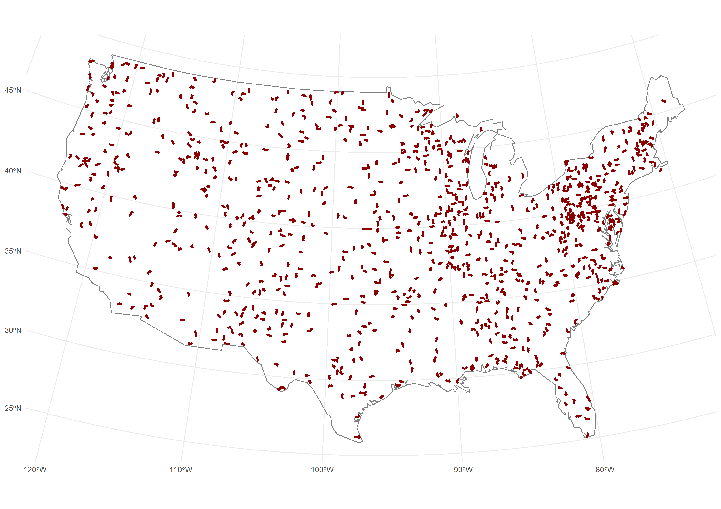**Supplementary figures**

**Fig. S1. Distribution of the 960 analysed routes of the United States Breeding Bird Survey across the contiguous USA states.** This represents a subset of USBBS routes which were consistently surveyed across the two timepoints of interest and surrounding years (2000, **2001**, 2002 and 2015, **2016**, 2017).

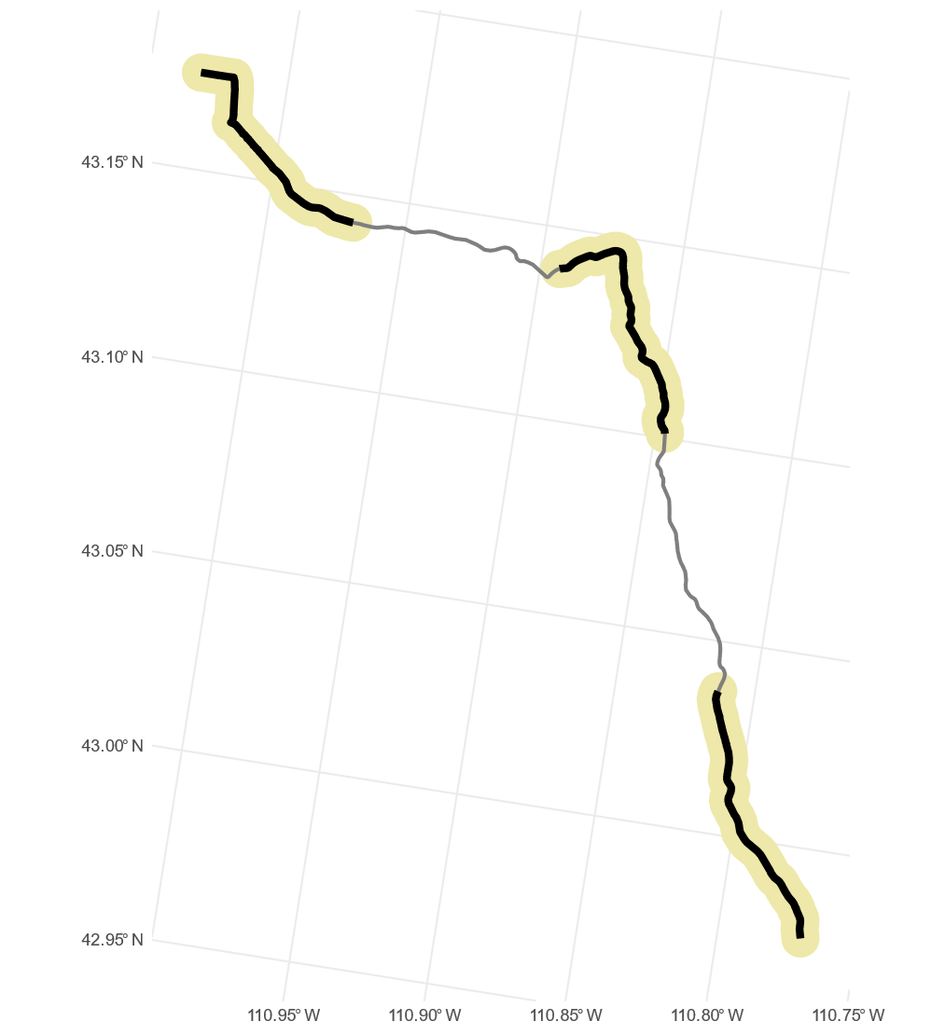**Fig. S2. Visual representation of a Breeding Bird Survey route segments and buffer.**

Each route is approximately 40km long. Visible are 5 segments, each representing 10 bird point counts processed as described in the methodology. In black, are segment 1, 3 and 5, which were the source of biodiversity and landscape data fitted by the modelling effort. The circular buffer from which landscape metrics were sampled is here presented in pale yellow. Buffers are 500 metres distant from each segment line, and buffer size was selected by comparing model fit between several shapes and sizes. In grey, are segment 2 and 4, which we excluded from the analysis to resolve pseudo-replication problems that would otherwise arise from the proximity.

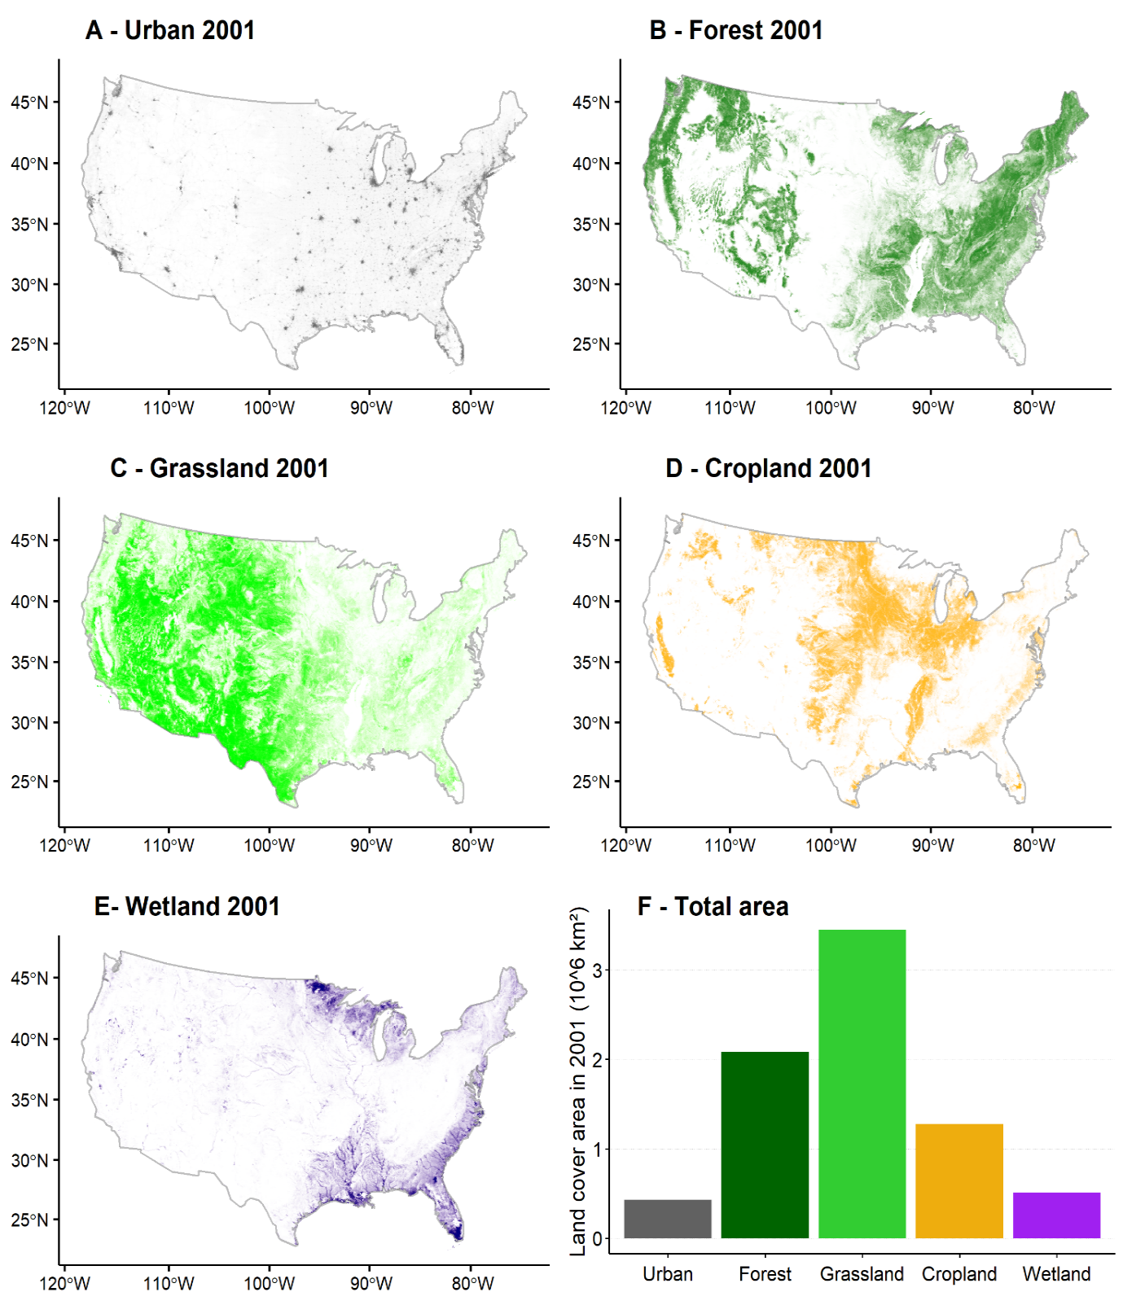**Fig. S3. Distributions of environmental covariates across the USA in 2001.**

Maps of the contiguous USA states showing the 2001 spatial distribution (A-E) and area (F) of each land cover included in the analysis. Land cover variables were produced as aggregate: Urban (panel A) [an aggregate of the Developed-Open Space (sub-class 21), Developed-Low Intensity (22), Developed-Medium Intensity (23), Developed-High Intensity classes]; Forest (panel B) [an aggregate of the Deciduous Forest (41), Evergreen Forest (42), Mixed Forest (43) classes]; Wetland (panel C) [an aggregate of the Woody Wetland (90) and Herbaceous Wetland (95) classes]; Grassland (panel D) [an aggregate of the Shrub (52), Grassland/Herbaceous (71), Pasture/Hay (81) classes] and Cropland (panel E) [cultivated Crops (82) sub class].

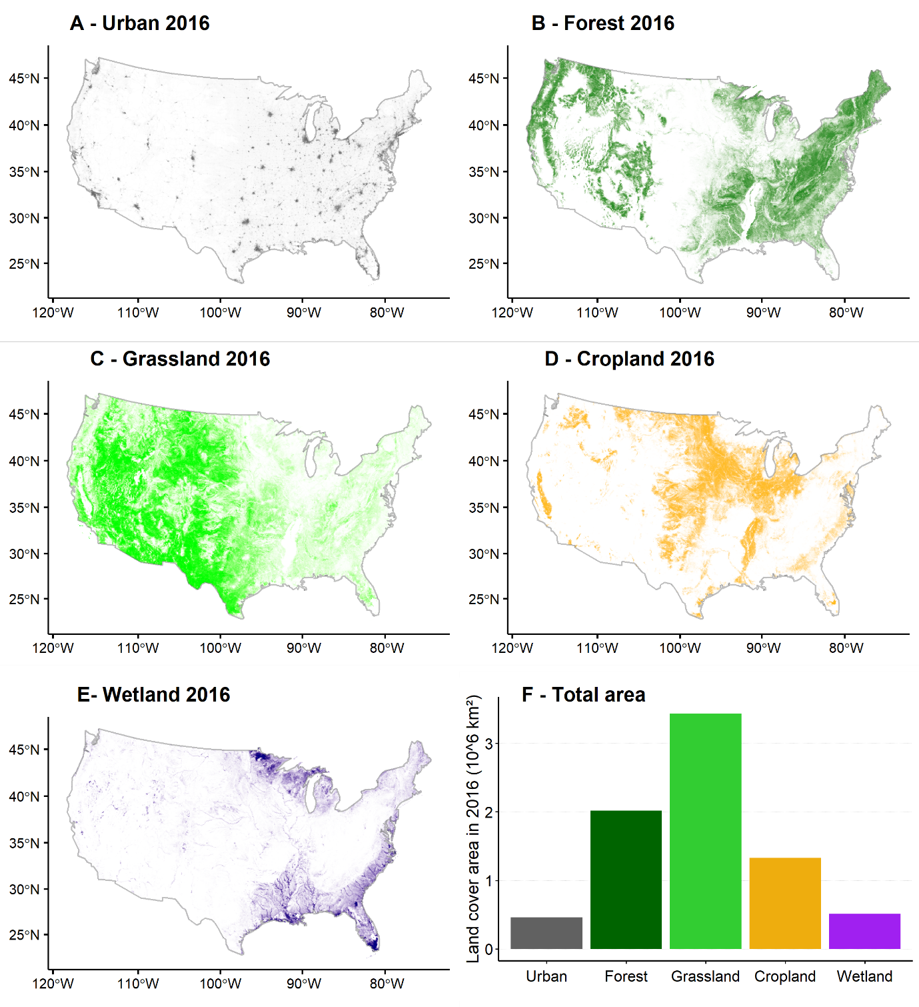**Fig. S4. Distributions of environmental covariates across the USA in 2016.**

Maps of the contiguous USA states showing the 2016 spatial distribution (A-E) and area (F) of each land cover included in the analysis. Land cover variables were produced as aggregate: Urban (panel A) [an aggregate of the Developed-Open Space (sub-class 21), Developed-Low Intensity (22), Developed-Medium Intensity (23), Developed-High Intensity classes]; Forest (panel B) [an aggregate of the Deciduous Forest (41), Evergreen Forest (42), Mixed Forest (43) classes]; Wetland (panel C) [an aggregate of the Woody Wetland (90) and Herbaceous Wetland (95) classes]; Grassland (panel D) [an aggregate of the Shrub (52), Grassland/Herbaceous (71), Pasture/Hay (81) classes] and Cropland (panel E) [cultivated Crops (82) sub class].

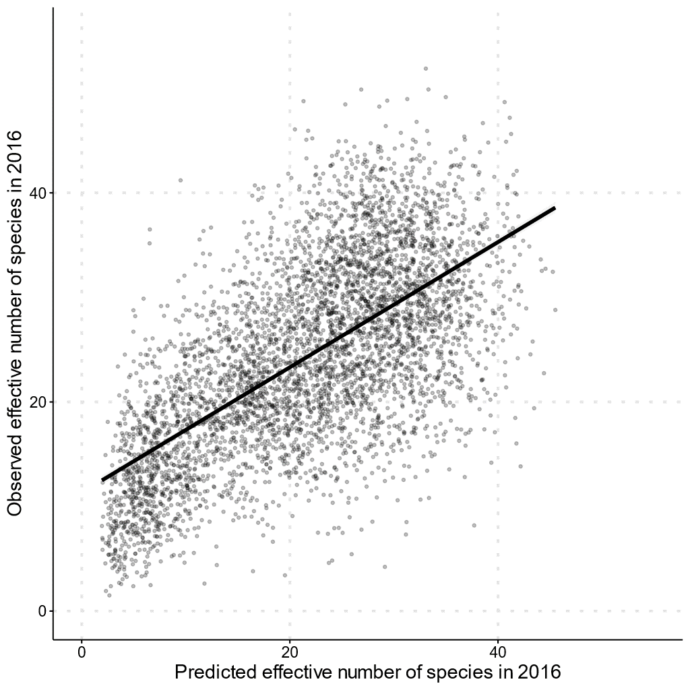**Fig. S5. Correlation between the observed effective number of species in 2016 and the model predicted effective number of species in 2016.** Scatter plot of the observed effective number of species in 2016, across the 4800 analysed US bird communities (including all segments, not only 1-3-5 as per model fit), against the model predicted value of effective number of species.The model was able to explain 42% of the observed variation. The model-predicted effective number of species was significantly correlated to the observed effective number of species in 2016 (Pearson’s r = 0.65, df = 4798, p < 0.01).

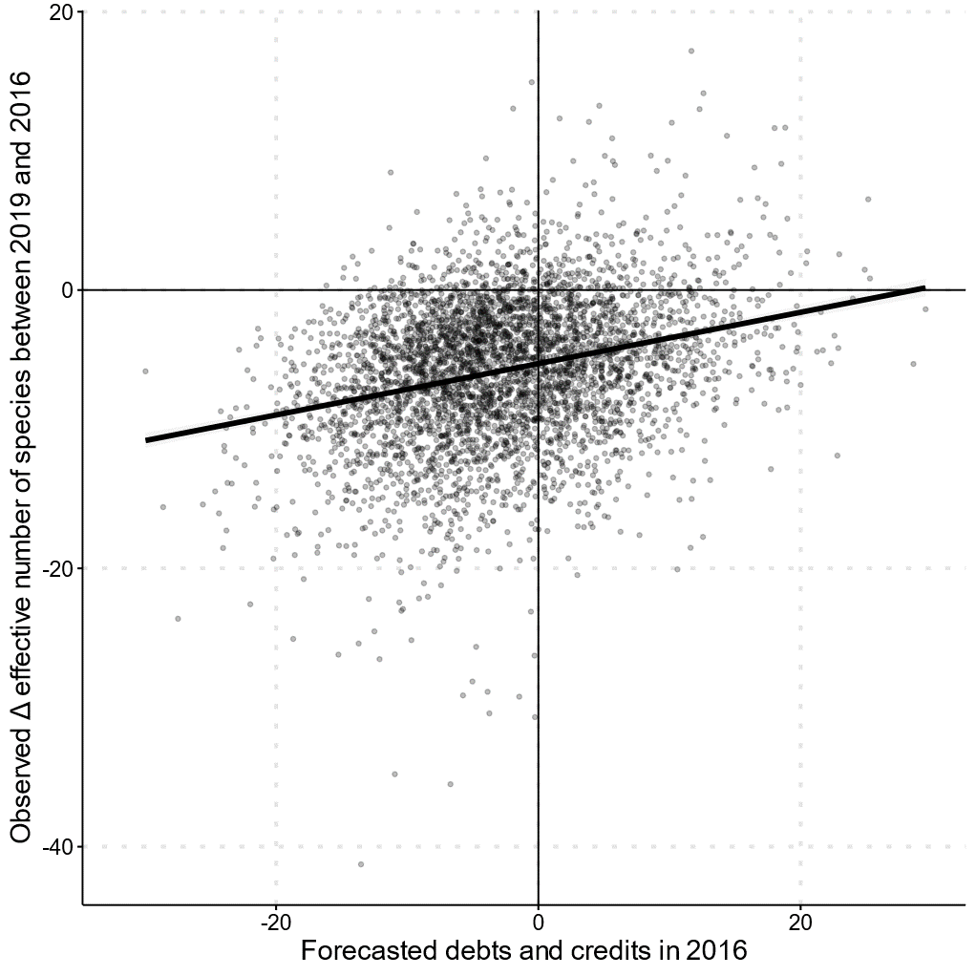**Fig. S6. Correlation between the observed change in effective number of species between 2019 and 2016 and the model forecasted extinction debts and colonisation credits.** Scatter plot of the observed change in effective number of species between 2019 and 2016 against the model forecasted values of extinction debt and colonisation credits. Data from 4233 US bird communities (subset of the 4800 communities with data available also in 2019). Despite the relatively short time interval (we expect most of these debts and credits will require longer before they can be fully realised), changes in effective number of species since 2016 have overall been in the direction predicted by our model (Pearson correlation test, r = 0.28, df=4233, p <0.001).

**Fig. S7. Map of the contiguous USA showing the uncertainty around the predictions of extinction debt and colonisation credit.** The uncertainty was computed by sampling from the posteriors and computing the difference between our equilibrium and legacy model predicted effective number of species 1000 times for each of the circa 92,000 landscape compositions mapped in the figure. The geometric coefficient of variation is presented in panel A, with these values computed as sqrt(exp(log(sd+1)^2)-1). Panels C and D show, respectively, the upper (97.5%) and lower (2.5%) credible intervals, while panel B is a copy of Fig.1 for reference when consulting the interval maps.

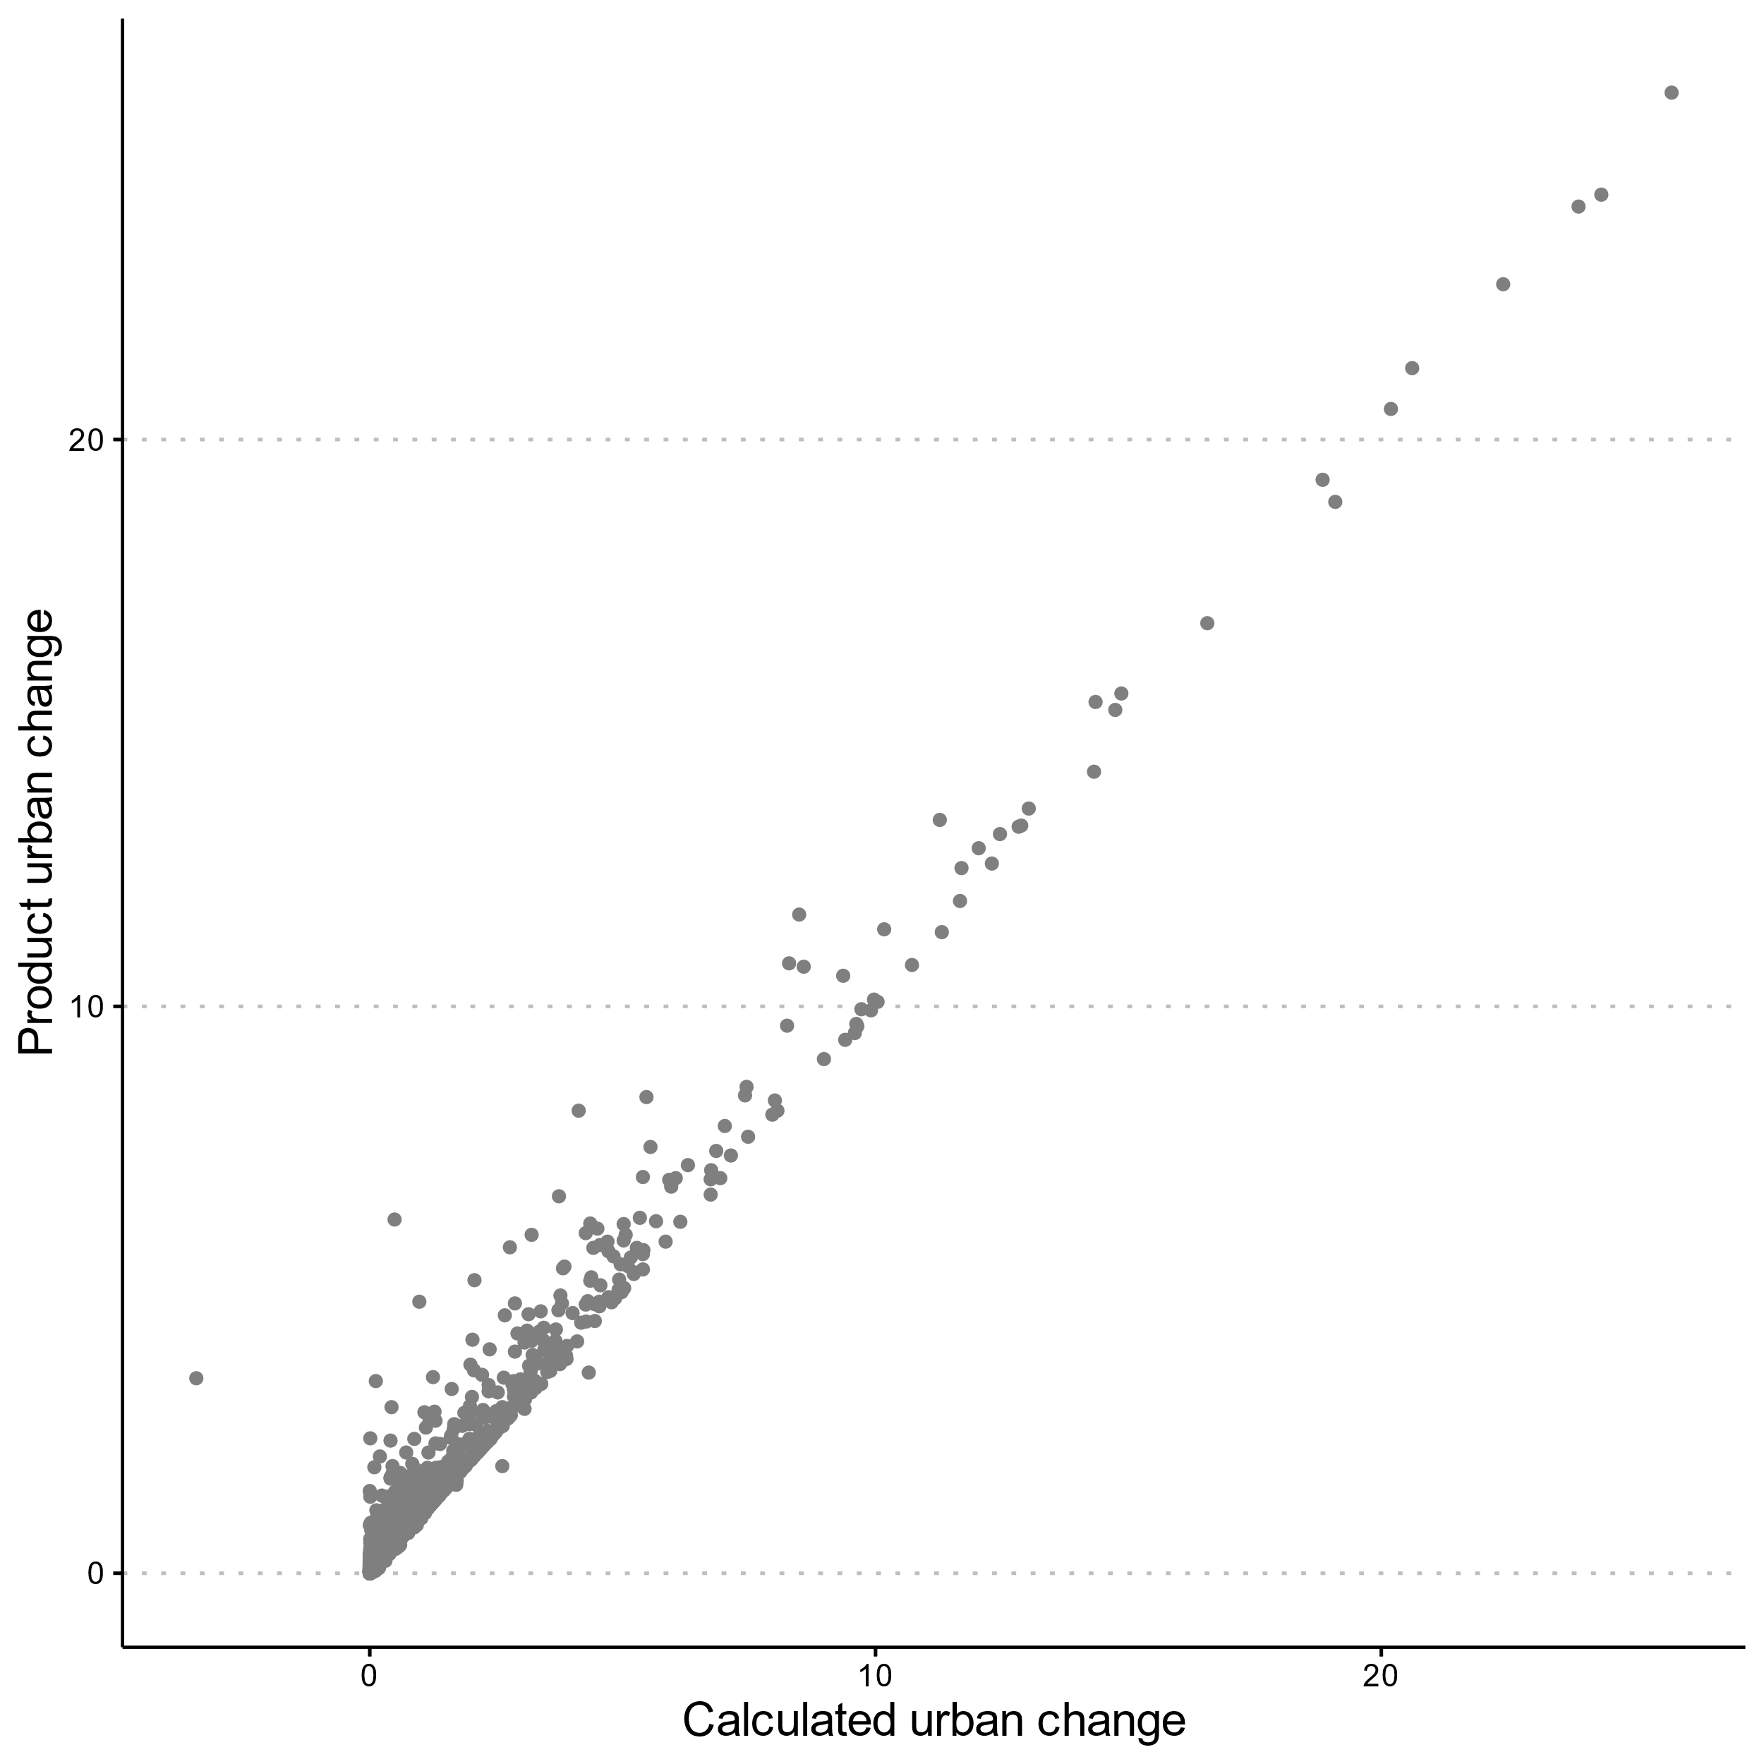**Fig. S8. Validation of land cover change data.** On the x-axis we show the percentage point change in the urban land cover between the years 2016 and 2001, as calculated using the two independent USGS land cover maps produced for the two years. On the y-axis, we show the values recently published in the “change product” map provided by the USGS40. We used only the urban land cover for this validation because this is the only land cover directly comparable between the static and the product change map. The change product map does not include the directionality of change in its published data. However, because the urban land cover has seen only increase (i.e. unidirectional change) over the 15-year period used in our analyses, it can therefore be used for this validation.

**Tables**

**Table S1. Descriptive statistics of the analysed variables.**

|  |  |  |  |  |  |
| --- | --- | --- | --- | --- | --- |
| Variable | Mean | Std. Dev | Median | Min | Max |
|  |  |  |  |  |  |
| ***Environmental covariates at t1(year 2001) and t2(year 2016) (numbers indicate proportions between 0 and 100)*** | | | | | |
| Urban t1 | 8.23 | 8.84 | 5.94 | 0.00 | 97.11 |
| Urban t2 | 8.64 | 9.54 | 6.01 | 0.00 | 97.30 |
| **Developed-openspace t1** | 3.56 | 3.41 | 3.06 | 0.00 | 44.06 |
| **Developed-openspace t2** | 3.67 | 3.57 | 3.08 | 0.00 | 43.92 |
| **Developed-low t1** | 1.46 | 3.07 | 0.52 | 0.00 | 38.41 |
| **Developed-low t2** | 1.54 | 3.28 | 0.55 | 0.00 | 38.90 |
| **Developed-medium t1** | 0.42 | 1.50 | 0.04 | 0.00 | 27.29 |
| **Developed-medium t2** | 0.52 | 1.76 | 0.05 | 0.00 | 28.30 |
| **Developed-medium t1** | 0.11 | 0.52 | 0.00 | 0.00 | 12.39 |
| **Developed-medium t2** | 0.15 | 0.62 | 0.00 | 0.00 | 13.15 |
| Forest t1 | 30.08 | 29.93 | 22.73 | 0.00 | 99.92 |
| Forest t2 | 30.19 | 29.40 | 22.36 | 0.00 | 98.08 |
| **Deciduous forest t1** | 16.82 | 22.67 | 4.62 | 0.00 | 93.34 |
| **Deciduous forest t2** | 16.45 | 22.36 | 4.40 | 0.00 | 93.52 |
| **Evergreen forest t1** | 11.31 | 20.76 | 0.93 | 0.00 | 98.90 |
| **Evergreen forest t2** | 10.86 | 19.69 | 0.93 | 0.00 | 98.73 |
| **Mixed forest t1** | 5.97 | 9.61 | 1.19 | 0.00 | 67.74 |
| **Mixed forest t2** | 6.01 | 9.60 | 1.23 | 0.00 | 67.86 |
| Wetland t1 | 6.66 | 13.21 | 0.99 | 0 | 96.72 |
| Wetland t2 | 6.68 | 13.22 | 1.03 | 0 | 96.72 |
| **Woody wetlands t1** | 5.75 | 11.78 | 0.55 | 0.00 | 94.98 |
| **Woody wetlands t2** | 5.80 | 11.86 | 0.56 | 0.00 | 96.54 |
| **Herbaceous wetlands t1** | 1.67 | 5.65 | 0.16 | 0.00 | 94.43 |
| **Herbaceous wetlands t2** | 1.65 | 5.55 | 0.17 | 0.00 | 94.17 |
| Grassland t1 | 33.15 | 31.13 | 21.87 | 0 | 100.00 |
| Grassland t2 | 32.81 | 30.82 | 21.29 | 0 | 100.00 |
| **Grassland herbaceous t1** | 9.58 | 19.88 | 0.88 | 0.00 | 99.87 |
| **Grassland herbaceous t2** | 9.84 | 19.77 | 1.22 | 0.00 | 99.87 |
| **Shrubland t1** | 12.88 | 25.11 | 0.83 | 0.00 | 100.00 |
| **Shrubland t2** | 13.14 | 24.91 | 1.09 | 0.00 | 100.00 |
| **Pasture t1** | 9.13 | 13.79 | 2.78 | 0.00 | 84.32 |
| **Pasture t2** | 8.50 | 12.96 | 2.59 | 0.00 | 83.26 |
| Cropland t1 | 19.30 | 28.22 | 1.86 | 0.00 | 95.83 |
| Cropland t2 | 19.94 | 28.42 | 2.57 | 0.00 | 95.82 |
| Temp t1 | 18.51 | 4.25 | 18.32 | 6.64 | 30.22 |
| Temp t2 | 18.65 | 3.97 | 18.44 | 6.74 | 32.08 |
| **Barren land t1** | 0.42 | 2.58 | 0.02 | 0.00 | 58.56 |
| **Barren land t2** | 0.41 | 2.48 | 0.03 | 0.00 | 60.92 |
| **Water t1** | 1.41 | 3.91 | 0.13 | 0.00 | 48.25 |
| **Water t2** | 1.41 | 3.85 | 0.13 | 0.00 | 48.32 |
| Landscape heterogeneity t1 | 3.79 | 1.76 | 3.57 | 1.00 | 10.71 |
| Landscape heterogeneity t2 | 3.89 | 1.82 | 3.68 | 1.00 | 10.72 |
| Time of day t2 (minutes after earliest survey overall) | 329.2 | 175.91 | 327.00 | 0.00 | 860.00 |
|  | | | | | |
| ***Change in environmental covariates between t2 and t1, 2016 and 2001*** | | | | | |
| Delta urban | 0.31 | 1.32 | 0.00 | 0.00 | 25.74 |
| **Delta pos urban** | 0.31 | 1.32 | 0 | 0 | 25.74 |
| **Delta neg urban** | - | - | - | - | - |
| Delta forest | -0.61 | 4.09 | 0.00 | -78.68 | 45.04 |
| **Delta pos forest** | 0.37 | 1.68 | 0.00 | 0 | 45.04 |
| **Delta neg forest** | 0.99 | 3.63 | 0.00 | 0 | 78.68 |
| Delta wetland | 0.019 | 0.45 | 0.00 | -5.57 | 10.53 |
| **Delta pos wetland** | 0.06 | 0.38 | 0 | 0 | 10.53 |
| **Delta neg wetland** | 0.04 | 0.22 | 0 | 0 | 5.57 |
| Delta grassland | -0.34 | 4.70 | -0.10 | -45.04 | 78.66 |
| **Delta pos grassland** | 0.87 | 3.59 | 0.00 | 0 | 78.66 |
| **Delta neg grassland** | 1.21 | 2.66 | 0.10 | 0 | 45.04 |
| Delta cropland | 0.63 | 2.28 | 0.00 | -23.91 | 31.05 |
| **Delta pos cropland** | 0.78 | 2.06 | 0.00 | 0 | 31.05 |
| **Delta neg cropland** | 0.14 | 0.84 | 0.00 | 0 | 23.91 |
|  | | | | | |
| ***Biodiversity variables*** | | | | | |
| Effective no. species t2 | 24.29 | 9.05 | 24.18 | 1.50 | 51.88 |
| Effective no. species t1 | 23.67 | 9.27 | 23.64 | 1.35 | 54.16 |
| Delta Effective no. species | 0.62 | 5.84 | 0.49 | -32.04 | 27.84 |
| Species richness t2 | 43.02 | 12.74 | 44.00 | 4.00 | 87.00 |
| Species richness t1 | 43.15 | 13.20 | 44.00 | 2.00 | 89.00 |
| Delta species richness | -0.12 | 7.70 | 0 | -37.00 | 31.00 |

**Table S2. Summary of parameter estimates of the equilibrium and legacy model components.** Parameters are subdivided according to the model sections as described in the model development section of the Supplementary Materials. Values of rhat indicate chain convergence (ideally these should approach 1), while the ess_bulk and ess_tail indicate the effective sample size, either at the bulk or tails, of the posterior distributions, with values above 400 being considered satisfactory.

|  |  |  |  |  |  |  |  |  |
| --- | --- | --- | --- | --- | --- | --- | --- | --- |
| Parameter | mean | median | SD | q5 | q95 | rhat | ess_bulk | ess_tail |
| *Equilibrium model [Eq. 5]* | | | | | | | | |
| intercept | 0.992 | 0.710 | 0.946 | 0.058 | 2.893 | 1.001 | 4544 | 2206 |
| urban | 0.618 | 0.498 | 0.503 | 0.048 | 1.633 | 1.000 | 3239 | 1919 |
| forest | 1.334 | 1.267 | 0.711 | 0.246 | 2.591 | 1.000 | 2275 | 1693 |
| grass | 1.089 | 0.998 | 0.676 | 0.149 | 2.312 | 1.000 | 3196 | 1728 |
| crop | 1.459 | 1.423 | 0.777 | 0.260 | 2.802 | 1.001 | 2557 | 1908 |
| wet | 1.642 | 1.594 | 0.725 | 0.514 | 2.903 | 1.000 | 1557 | 1098 |
| urban^2 | -0.390 | -0.382 | 0.194 | -0.721 | -0.087 | 1.001 | 1637 | 1018 |
| forest^2 | -0.376 | -0.361 | 0.198 | -0.729 | -0.072 | 1.000 | 1460 | 1538 |
| grass^2 | -0.587 | -0.577 | 0.181 | -0.897 | -0.309 | 1.002 | 1368 | 1227 |
| crop^2 | -0.732 | -0.722 | 0.257 | -1.179 | -0.318 | 1.001 | 1623 | 1668 |
| wet^2 | -0.314 | -0.289 | 0.198 | -0.669 | -0.032 | 1.001 | 1181 | 997 |
| urban * forest | 0.152 | 0.155 | 0.071 | 0.030 | 0.262 | 1.001 | 2327 | 1974 |
| urban * grass | 0.101 | 0.096 | 0.526 | -0.786 | 0.955 | 1.002 | 1419 | 2019 |
| urban * crop | -0.304 | -0.298 | 0.496 | -1.124 | 0.496 | 1.001 | 2506 | 2698 |
| forest * grass | 0.297 | 0.301 | 0.363 | -0.295 | 0.907 | 1.001 | 1453 | 2426 |
| forest * crop | -0.111 | -0.106 | 0.342 | -0.679 | 0.435 | 1.004 | 1998 | 2618 |
| grass * crop | 0.341 | 0.334 | 0.396 | -0.310 | 0.987 | 1.000 | 1688 | 2440 |
| wet * urban | 0.625 | 0.631 | 0.466 | -0.156 | 1.391 | 1.001 | 2574 | 2926 |
| wet * forest | -0.794 | -0.800 | 0.346 | -1.353 | -0.230 | 1.002 | 2189 | 2418 |
| wet* grass | 0.866 | 0.872 | 0.447 | 0.131 | 1.576 | 1.002 | 1843 | 2306 |
| wet * crop | -0.918 | -0.920 | 0.330 | -1.460 | -0.379 | 1.001 | 2399 | 2897 |
| urban^2 * forest | -0.187 | -0.186 | 0.054 | -0.278 | -0.097 | 1.002 | 2366 | 2951 |
| urban^2 * grass | 0.058 | 0.058 | 0.060 | -0.040 | 0.157 | 1.000 | 2667 | 3062 |
| urban^2 * wet | -0.089 | -0.088 | 0.087 | -0.231 | 0.058 | 1.001 | 2802 | 2954 |
| urban^2 * crop | -0.120 | -0.120 | 0.099 | -0.284 | 0.040 | 1.000 | 2703 | 2640 |
| forest^2 * urban | 0.110 | 0.110 | 0.052 | 0.024 | 0.195 | 1.003 | 1650 | 2724 |
| forest^2 * crop | 0.085 | 0.085 | 0.056 | -0.007 | 0.178 | 1.001 | 2189 | 3014 |
| forest^2 * grass | 0.051 | 0.050 | 0.049 | -0.028 | 0.134 | 1.000 | 1782 | 2590 |
| forest^2 * wet | -0.026 | -0.026 | 0.070 | -0.143 | 0.089 | 1.001 | 2234 | 2711 |
| grass^2 * urban | -0.038 | -0.038 | 0.103 | -0.206 | 0.135 | 1.001 | 1494 | 2459 |
| grass^2 * forest | 0.017 | 0.018 | 0.063 | -0.091 | 0.121 | 1.002 | 1635 | 2488 |
| grass^2 * crop | 0.027 | 0.027 | 0.060 | -0.069 | 0.127 | 1.000 | 1742 | 2550 |
| grass^2 * wet | -0.046 | -0.046 | 0.079 | -0.173 | 0.082 | 1.000 | 1925 | 2469 |
| crop^2 * urban | 0.180 | 0.178 | 0.110 | 0.002 | 0.368 | 1.002 | 3037 | 3184 |
| crop^2 * forest | 0.050 | 0.050 | 0.061 | -0.051 | 0.150 | 1.004 | 2194 | 2528 |
| crop^2 * grass | -0.092 | -0.093 | 0.063 | -0.194 | 0.013 | 1.002 | 1820 | 2530 |
| crop^2 * wet | 0.136 | 0.136 | 0.068 | 0.022 | 0.247 | 1.001 | 2481 | 3363 |
| wet^2 * urban | -0.098 | -0.097 | 0.102 | -0.269 | 0.069 | 1.001 | 3311 | 2922 |
| wet^2 * forest | 0.218 | 0.218 | 0.059 | 0.122 | 0.314 | 1.002 | 2634 | 2525 |
| wet^2 * grass | -0.205 | -0.205 | 0.067 | -0.314 | -0.094 | 1.004 | 2252 | 2903 |
| wet^2 * crop | 0.189 | 0.190 | 0.059 | 0.091 | 0.284 | 1.001 | 2791 | 3057 |
| *Temporal legacy model [Eq. 7]* | | | | | | | | |
| γ pos urban | 0.490 | 0.474 | 0.291 | 0.045 | 0.949 | 1.002 | 8017 | 2720 |
| γ pos forest | 0.397 | 0.344 | 0.277 | 0.032 | 0.909 | 1.001 | 5538 | 2592 |
| γ pos grass | 0.194 | 0.136 | 0.186 | 0.013 | 0.603 | 1.002 | 3451 | 2489 |
| γ pos crop | 0.462 | 0.446 | 0.276 | 0.055 | 0.926 | 1.003 | 6575 | 2288 |
| γ pos wet | 0.385 | 0.324 | 0.291 | 0.022 | 0.921 | 1.001 | 6675 | 2290 |
| γ neg forest | 0.193 | 0.139 | 0.180 | 0.013 | 0.582 | 1.001 | 3104 | 2268 |
| γ neg grass | 0.515 | 0.520 | 0.276 | 0.075 | 0.945 | 1.002 | 5292 | 2942 |
| γ neg crop | 0.541 | 0.555 | 0.279 | 0.075 | 0.961 | 1.000 | 5068 | 2538 |
| γ neg wet | 0.448 | 0.429 | 0.282 | 0.039 | 0.930 | 1.001 | 5842 | 2367 |
| *Static covariates* | | | | | | | | |
| time of day | 0.005 | 0.005 | 0.000 | 0.004 | 0.006 | 1.001 | 3680 | 2793 |
| temperature | 1.515 | 1.513 | 0.252 | 1.105 | 1.928 | 1.004 | 946 | 1066 |
| temperature^2 | -0.040 | -0.040 | 0.007 | -0.051 | -0.029 | 1.004 | 980 | 1055 |
| landscape heterogeneity | 2.990 | 2.994 | 0.579 | 2.026 | 3.925 | 1.001 | 3749 | 2838 |
| SD observer random effect | 3.866 | 3.863 | 0.154 | 3.622 | 4.119 | 1.003 | 2204 | 2675 |

**Table S3. Parameter summary of the linear model describing the effect of different types and directionalities of land cover change on the magnitude of our predicted extinction debts and colonisation credits.** Coefficient estimates and uncertainty are also presented in Fig. 4 of the main text. Note that the means and standard deviations presented are the result of uncertainty propagation by fitting a GLM to 1000 response variable sets based on predictions from posterior draws and subsequently sampling 1000 times from each GLM fit parameter distributions before computing summary statistics.

|  |  |  |  |  |
| --- | --- | --- | --- | --- |
| **Parameter** | **mean** | **sd** | **2.5%** | **97.5%** |
| **Intercept** | 0.046 | 0.010 | 0.026 | 0.066 |
| **Urban gain** | -0.115 | 0.020 | -0.156 | -0.075 |
| **Forest gain** | -0.018 | 0.021 | -0.059 | 0.024 |
| **Forest loss** | 0.085 | 0.003 | 0.08 | 0.09 |
| **Grassland gain** | 0.006 | 0.020 | -0.034 | 0.046 |
| **Grassland loss** | 0.039 | 0.019 | 0.002 | 0.077 |
| **Cropland gain** | -0.059 | 0.023 | -0.104 | -0.149 |
| **Cropland loss** | -0.005 | 0.022 | -0.048 | 0.038 |
| **Wetland gain** | 0.036 | 0.025 | -0.013 | 0.085 |
| **Wetland loss** | -0.051 | 0.025 | -0.101 | -0.001 |